**Daphne Jackson Trust Fellowship application, Jan 2018**

**Applicant:** Dr. Elizabeth Hughes

**Supervisor:** Dr. Edward Wallace

**Host Organization:** Institute for Cell Biology, School of Biological Sciences, University of Edinburgh.

**Project Title:**  Dynamic mRNA processing in response to environmental stimuli in the fungal pathogen *Cryptococcus neoformans*.

**Reasons for applying for a Fellowship**

I am a skilled and highly motivated molecular biologist with 10 years lab-based experience, 6 post-doctoral. In order to successfully compete in the current job market I need to update my skillset and access the rapidly advancing technologies and evolving practices in my field.

Through the Daphne Jackson Fellowship and Medical Research Scotland I aim to update my current skills while gaining expertise in new technologies and forging relationships with prospective employers and mentors to ensure the success of my career.

My PhD investigated the relationship of HIV viral populations and disease progression, primarily via evolutionary analysis of isolates infecting lymphoid and non-lymphoid tissues 1,2. My first author paper reported the discovery of a previously unknown dormant HIV population in the brain and has over 100 citations to date. 1.

As a post-doc, I examined Hepatitis C Virus replicative processes by investigating a non-structural protein (NS5B) implicated in RNA-dependent-RNA-polymerase activity. I optimized bacterial expression systems and purified this protein.

I also investigated the structure/function of the Major Outer Membrane Proteins of *Chlamydia trachomatis* and *psittaci* where I cloned and expressed wild-type and short variable domain 4 mutated proteins and functionally reconstituted them at the single-channel level.3

I then joined a leading bio-safety testing facility, BioReliance, as the research and development scientist and developed a wide range of molecular based assays for clients as well as providing technical training and support for colleagues.

I took a career break to raise my family. My husband works in the marine industry as a consultant which regularly takes him away from home. Due to this and prohibitive childcare costs we decided I would put my career on hold and take on the administrative side of my husband’s business.

Both of my children attend high school and are mature and resilient enough for me to return to my chosen career.

After applying for numerous positions, without success, I learned of the Daphne Jackson career re-entry Fellowship. This is an ideal opportunity for me because the emphasis is on improving employability through updating existing, and gaining new skills. This is exactly what I need to become competitive in the highly skilled and fast moving molecular biology field. I am excited to re-engage with the scientific community and find research both rewarding and enlightening and I look forward to returning to my chosen career.

Word count: 387

**Research Summary**

*Cryptococcus neoformans* is a fungus that lives in the environment and infects people through inhalation of spores/desiccated yeast cells. Infection is rare in healthy individuals and most cases occur in individuals who have a weakened immune system. Infection of the lung causes a pneumonia-like illness, however, if it spreads to the brain, life-threatening meningitis can occur. Approximately 1 million cases occur each year globally resulting in estimated deaths as high as 600,0004. I will investigate the dynamic processing of mRNA and gene expression profiles of *C. neoformans* in a host-like environment.

**Aim 1:** How does the rapid change in environment from soil/vegetation to a mammalian lung affect the gene regulation of *C. neoformans*? I will examine what happens when this fungus reactivates in an environment alien to its normal life cycle. Identifying critical processes provides valuable knowledge for drug design.

**Aim 2**: Upon presentation to the lung *C. neoformans* will encounter a number of foreign bodies, some of which will be commensal and/or pathogenic bacteria. Working with my host lab’s collaborator, Elizabeth Ballou, I will investigate fungal interaction with lung-resident bacteria to examine how these interactions modify transcriptional activity of *C. neoformans*.

**Aim 3**: In the mammalian lung the first line of defense is the mucosal lining of the airways. This contains soluble effector molecules which help eradicate foreign bodies. One such molecule is surfactant protein-D (SP-D) which has anti-microbial properties and can regulate the immune response. SP-D will be one of the first effector molecules to interact with this pathogenic fungus and has been shown to help with its survival. I will investigate the binding of this molecule to *C. neoformans* to determine what changes, if any, occur in gene expression. Identifying unique pathways *Cryptococcus* uses to cause disease will provide unique targets for drug design.

To address each of these aims, I will measure mRNA processing during exposure to these conditions using quantitative PCR (RT-qPCR) and further analyze with RNA-seq. Measuring the intermediate step between genes and proteins effectively bridges the gap between the genetic code and functional proteins providing information on the amount of gene activity.

Word count: 349

**Abstract**

*C. neoformans* is an accidental pathogen of mammals. Its natural life cycle is that of an environmental saprophyte. The mammalian lung is an alien environment yet somehow this fungus can circumvent a myriad of defenses to cause disease. Upon inhalation into a host, *Cryptococcus* cells transition from spores/desiccated yeast into actively replicating virulent yeast cells. This transformation must be associated with dynamic regulation of mRNA and hence gene expression. What happens to *Cryptococci* when they reactivate within a mammalian host? I will investigate this phenomenon during the early stages of infection in detail. I will use quantitative and qualitative methods to examine differential gene expression of *Cryptococcus* under different environmental stimuli. Gene expression profiles represent a snapshot of cellular metabolism at the molecular level and may provide insights into novel therapeutic methods for drug discovery.

**Host Organization**

As one of the UK’s leading research facilities Edinburgh University provides a state-of-the-art environment for cellular and molecular biology.

The Centre for Synthetic and Systems Biology, in the Institute for Cell Biology, is a unique inter-disciplinary environment with a track record for multi-disciplinary research. Included is the Edinburgh Genome Foundry (a world class facility for automated DNA design and assembly) and EdinOmics providing expertise in quantitative biochemistry including up-scaling and automation of RT-qPCR. There are facilities for cell imaging (LEAP and single cell analysis and microscopy groups) and for innovative data analysis and mechanistic modelling.

Dr. Wallace, of the Institute for Cell Biology, has agreed to be my supervisor for the duration of the fellowship. Dr. Wallace is a quantitative biologist specializing in fungal RNA processing. Working with him will allow me to build on my existing skills in the field of molecular biology whilst learning new techniques including high throughput RT-qPCR, cDNA library preparation and high throughput sequencing (RNA-seq), lab automation, bioinformatics, and working with large data sets. This will provide me with crucial work experience in one of Scotland’s world-class universities and equip me with specific skills in high demand in biomedical research and biotechnology industries. Dr. Ballou is an expert in *C. neoformans* biology, including relevant culture conditions and models of host-pathogen interaction required for this proposal. Dr. Ballou will contribute ad hoc advice and training as well as support professional development. Dr. Bayne (PDRA/Lab Manager) has 30 years of experience in molecular biology techniques and will be invaluable during my re-training and introduction to new concepts and technologies.

Edinburgh University supports academic and personal development through the Institute for Academic Development. This program provides workshops and courses on academic writing, career management and development, data management, funding opportunities, ethics, teaching and supervising students. During my fellowship I intend to make full use of these resources to enhance my personal and professional qualifications to help advance my career. Within the Institute for Cell Biology there is also a very dynamic seminar series covering a wide range of topics from internal and external speakers.

**Supervisor:** Dr. Edward Wallace. Sir Henry Dale Fellow (Wellcome Trust/Royal Society Early Career Research Fellow). Institute for Cell Biology, School of Biological Sciences, Edinburgh University.

**Collaborator:** Dr. Elizabeth Ballou. Sir Henry Dale Fellow and Lecturer. Institute for Microbiology and Infection, School of Biosciences, University of Birmingham.

Word Count: 392**Retraining Program** (See Appendix 1)

In order to carry out the proposed aims of my fellowship application I will have to learn:

* How to culture and extract RNA from Cryptococcus.
* How to identify and phenotype Cryptococcus using various microscopic techniques and stains.
* Lab automation to enable processing of large numbers of RT-qPCR.
* cDNA library preparation for next generation sequencing – a technique developed during my career break.
* Bio-Informatics to analyze the large data sets that will be produced. These have greatly advanced during my career break.

In order to update my skillset and become relevant in my research field I will be required to:

* Refresh my knowledge on RNA manipulation and RT-qPCR.
* Learn how to use updated tools/equipment for these methods.
* Increase my relevancy by investing in myself through training courses in new technologies within the molecular biology field.

This fellowship will increase my employability by bridging my skills gap using a framework for structured training of relevant skills in demand in today’s job market. I will train under the guidance of Dr. Wallace, Dr. Ballou and Dr. Bayne who are all proficient in all the necessary techniques and are committed to supporting me and my endeavor to return to the workforce. My training will build on my current skills to update my expertise while developing new in-demand skills and forging new relationships in a work environment.

I have identified courses that will complement my training and these are available at Edinburgh University. The Wellcome Centre Microscopy Course, run by Dr. Kelly, at the Wellcome Trust Centre for Cell Biology and Bioinformatics for Genomics, a 5 day workshop run at the Edinburgh Genomics Centre (£750). I will also have access to the Institute for Academic Development providing many opportunities for education to increase my knowledge and relevancy by investing in my personal and professional development.

During my training I would also like to attend relevant conferences as these provide a national/international platform for sharing information and ideas and keeping up to date with the latest innovations and advancements. Some upcoming conferences within the field of mycology are:

* British Society for Medical Mycology, March 2019, Sheffield (Annual).
* Human Fungal Pathogens, May 2019, France (Biennial).
* 6th International Conference on Mycology and Fungal Infections, Oct 2019, UAE.
* 11th International Conference on Cryptococcus and Cryptococcosis, 2020, Uganda.
* International Society for Human and Animal Mycology, March 2021, India.

Word count: 387

**Dynamic mRNA processing in response to environmental stimuli in the fungal pathogen *Cryptococcus neoformans*.**

**Background:**

*C. neoformans* is an opportunistic facultative saprophyte and the causative agent of cryptococcosis. 5,6 Typically associated with dry pigeon-guano, soil and decaying wood it is a free living fungus, however, it is able to adapt, survive and proliferate within a mammalian host to cause disease.

The ecology and long-term disease progression of *C. neoformans* is well characterized, however, few studies have examined the differential gene expression and regulation of *C. neoformans* during early stages of infection. The ability to investigate its genetic response to environmental stimuli is a powerful tool to elucidate the adaptive response required for this accidental pathogen to survive in a hostile environment. I will examine in detail what happens when this organism reactivates within the lung.

**Aim 1: What environmental stimuli in the host trigger an acute stress response in *C. neoformans*?**

Current knowledge of the early events in *C. neoformans* infection are based on research using animal models or *in vitro* culture methods, primarily in rich fungal support media such as YPD during log phase growth. While these methods have produced useful data they do not accurately reflect the deposition of desiccated yeast into the lung environment, where nutrients are likely to be scarce.

Previous investigations carried out by Dr. Wallace, in collaboration with Dr. Ballou, were designed to dissect the contributions of host factors and temperature in shaping initial growth. In this pilot study a distinct physiological response (capsule induction) and differential RNA abundance were documented between the different conditions (See Appendix 2).

**Objective:**

I will identify what causes this phenotypic shift by analyzing differential gene expression using RT-qPCR over time to produce a snapshot of actively expressed genes under different environmental stimuli. This will highlight the important steps for infection and will provide me an opportunity to further develop my molecular and microbiology skillsets.

**Method:**

I will inoculate growth-arrested *C. neoformans* yeast cells grown in YPD (GA-Cn-YPD) into RPMI-1640 media and YPD + serum and incubate at 25⁰C and 37⁰C. I will determine any phenotypic changes (India ink stain for capsule induction) and extract RNA for analysis using RT-qPCR (primers against differentially expressed genes previously detected by RNA-seq in the Wallace lab). I will compare alterations in the gene profile in relation to phenotype.

Analysis of this data will determine future studies. If the addition of serum, a key host-relevant stimulus, is sufficient for capsule induction I will incubate GA-Cn-YPD in RPMI-1640 + purified albumin and RPMI-1640 + charcoal stripped FBS (CS-FBS). This will compare the effect of albumin and reduced levels of endotoxins and hormones (reduced in CS-FBS) on capsule induction. (Appendix 3).

If serum is not sufficient I will look at the impact removing phenol red from RPMI-1640 has on capsule induction. Phenol red has been described as a weak oestrogen7 and such steroids have been shown to inhibit *C. neoformans* growth8 and have shown a synergistic/additive *in vitro* activity with drugs currently used to treat *cryptococcosis* 9,10. Recently the physiological relevance of culture media has been questioned where the electrolyte and carbohydrate concentrations may result in irrelevant changes in cell behavior11. For example, RPMI-1640 has very low concentrations of Mg2+ and Ca2+ and elevated levels of PO42- . Mg2+ have been shown to act as a possible signal for capsule induction12. I will test MEM where these levels are close to that in human serum and CSF (Appendix 4).

**Aim 2**: **Investigate how bacterial cell wall components influence gene expression in *C. neoformans*.**

Cell wall fragments are increasingly recognized as important signaling molecules that can inhibit growth and virulence factors and influence morphology of microbes. The addition of fetal calf serum (FCS) to media induces capsule formation in *C. neoformans*13. The Ballou lab have shown that bacterial cell wall components (in serum) modify the morphology of *C. neoformans* from a normal yeast cell to a large polyploid titan cell.14. The peptidoglycan subunit muramyl dipeptide was identified as a component of serum associated with titan cell induction.

**Objective:**

I will examine the transcriptional response of *C. neoformans* exposed to bacterial cell wall components present in the lung. I will measure changes in gene expression and relate these, using microscopy, to key phenotypes to identify molecular mechanisms underlying these changes.

**Method:**

I will incubate GA-Cn-YPD and GA-Cn-YNB in serum-free media with purified components of bacterial cell walls. Namely, peptidoglycan subunits N-acetyl glucosamine (NAG), N-acetyl muramic acid (NAM) and muramyl dipeptide found in gram positive and negative bacteria; lipopolysaccharide found in gram negative bacteria and teichoic acid (a major surface antigen) found in gram positive bacteria. These reagents are all commercially available. I will incubate cells at 25⁰C and 37⁰C if capsule was induced at both temperatures in Aim 1. Otherwise, I will only carry out these experiments at 37⁰C. (Appendix 5). Depending on results from pilot studies I will further characterize the effect of lipopolysaccharide by incubating yeast cells with the subunits lipid-A (antigenic), core polysaccharide and/or o-polysaccharide.

I will examine the cells to determine any phenotypic changes and will extract RNA for analysis using RT-qPCR and RNA-seq to identify unknown enriched genes or pathways. This will involve training in RNA-seq, which was developed during my career break, and bioinformatics. New technology has given us high-capacity analysis of genes which makes it necessary to integrate informatics when solving biological problems.

**Aim 3**: **Investigate how SP-D influences gene expression in *C. neoformans*.**

Collectins, surfactant proteins A and D and mannose binding lectins (SP-A, SP-D and MBL’s), have previously been shown to bind to *C. neoformans* 15–19. *In vitro* studies suggest SP-A has little effect on *C. neoformans* 20. In contrast, SP-D binds acapsular yeast with a high affinity (and capsular yeast with a lower affinity) causing profound aggregation, increased phagocytosis and enhanced fungal survival 16,17,21,22.Previous studies, using animal models, have suggested a protective role for SP-D in infection 23.

**Objective:**

I will investigate if binding of SP-D affects *C. neoformans* directly by analyzing gene expression before and after binding of purified recombinant human SP-D (rh-SP-D). Direct binding of rh-SP-D may modulate gene expression in a synergistic or antagonistic way and could therefore reciprocally modulate virulence factors and enhance fungal survival.

**Method:**

I will incubate rh-SP-D (commercially available) with yeast cells in a microtiter plate at various concentrations. I will analyze the plates for agglutination ofCryptococci and extract RNA for further analysis using RT-qPCR and RNA-seq.

Functional profiling under differing stimuli may identify enriched pathways during the early phase of *C. neoformans* adaptation to the host lung. Analyzing the transcriptome of *C. neoformans* may lead to micro-evolutionary adaptationin the host lung and pave the way for possible new drug targets aimed at de-regulating virulence instead of directly killing the fungus.

**Challenges:**

Gene expression analysis involves a multi-step approach: harvesting cells, RNA isolation and removal of genomic DNA, cDNA synthesis and RT-qPCR/RNA-seq. Although all these steps are established and routine in the Wallace lab, this multi-step approach can introduce inter- and intra-sample variation which must be normalized in order to make sense of the data produced. Normalization is very important when comparing data generated from different experimental conditions24. I will normalize global RNA levels by spiking in a 1:100 ratio of methanol-fixed *Schizosaccaromyces pombe* using three reference genes. Analysis of RT-qPCR data can result in misrepresentation of the expression profiles obtained 25 I will overcome this by selecting 3-4 stably expressed reference controls and the mean of these will be taken. These will allow me to normalize differences in the amount and quality of starting material as well as in the efficiency of the reaction. RT-qPCR will be carried out under MIQE guidelines26.

Manipulation during the construction of the cDNA libraries can complicate the analysis of RNA-seq reads where PCR artefacts of short identical reads can be confused for genuine reflection of the RNA present. In order to overcome this limitation I will run 3 biological replicates and determine whether the same sequences are observed in each sample.

Normalization is an important prerequisite for quantitative data analysis of gene expression. Different normalization approaches can have significant effects on the distribution of the data and calculation of significant values (*P*-values)27,28. I will analyze RNA-seq data with DESeq2 in R. This will involve training in statistical concepts and methodologies used in the analysis of sequencing data and the use of the statistical package R and will be on-going.

During this project I will be dealing with many samples and genes. I will use the sate-of-the-art lab automation facilities at the Edinburgh Genome Foundry to automate RT-qPCR plate loading thereby reducing human error.

**Impact:**

This research is discovery driven and will advance knowledge regarding the initial stages of Cryptococcal infection in the lung. Through transcriptome and RNA-seq analysis new critical pathways and processes may be discovered providing possible routes for intervention and drug design. I expect this fellowship to lead to 3 peer reviewed papers, 2 as first author. This research will be presented at conferences and seminars in order to engage the wider community and forge future collaborations.

Word count: 1495

**Ethical approval and licenses**

This work is covered by the School of Biological Sciences' ethics assessment ewallac2-0002, "Dynamic RNA processing in adapting fungi". The proposed work will be entirely with model fungi grown in liquid or solid media in laboratory conditions. No work will be conducted with patients, nor with animals, nor with animal/human tissue. There will be no contact with clinical data.

Cryptococcus neoformans is a category 2 pathogen and the Wallace lab has all risk assessments in place, including biosafety and genetic modification, for the proposed work.

**Timetable**



1. Hughes, E. S., Bell, J. E. & Simmonds, P. Investigation of the dynamics of the spread of human immunodeficiency virus to brain and other tissues by evolutionary analysis of sequences from the p17gag and env genes. *J. Virol.* **71**, 1272–80 (1997).

2. Hughes, E. S., Bell, J. E. & Simmonds, P. Investigation of population diversity of human immunodeficiency virus type 1 in vivo by nucleotide sequencing and length polymorphism analysis of the V1/V2 hypervariable region of env. *J. Gen. Virol.* **78**, 2871–2882 (1997).

3. Hughes, E. S., Shaw, K. M. & Ashley, R. H. Mutagenesis and functional reconstitution of chlamydial major outer membrane proteins: VS4 domains are not required for pore formation but modify channel function. *Infect. Immun.* **69**, 1671–1678 (2001).

4. Park, B. J. *et al.* Estimation of the current global burden of cryptococcal meningitis among persons living with HIV/AIDS. *AIDS* **23**, 525–530 (2009).

5. Park, B. J. *et al.* Estimation of the current global burden of cryptococcal meningitis among persons living with HIV/AIDS. *AIDS* **23**, 525–530 (2009).

6. Harrison, T. S. The burden of HIV-associated cryptococcal disease. *AIDS* **23**, 531–532 (2009).

7. Berthois, Y., Katzenellenbogen, J. A. & Katzenellenbogen, B. S. Phenol red in tissue culture media is a weak estrogen: implications concerning the study of estrogen-responsive cells in culture. *Proc. Natl. Acad. Sci. U. S. A.* **83**, 2496–500 (1986).

8. Welshons, W. V., Wolf, M. F., Murphy, C. S. & Jordan, V. C. Estrogenic activity of phenol red. *Mol. Cell. Endocrinol.* **57**, 169–178 (1988).

9. Butts, A. *et al.* Estrogen Receptor Antagonists Are Anti-Cryptococcal Agents That Directly Bind EF Hand Proteins and Synergize with Fluconazole In Vivo. *MBio* **5**, e00765-13 (2014).

10. Mohr, J. A., Long, H., McKown, B. A. & Muchmore, H. G. *In vitro* susceptibility of *Cryptococcus neoformans* to steroids. *Med. Mycol.* **10**, 171–172 (1972).

11. McKee, T. J. & Komarova, S. V. Is it time to reinvent basic cell culture medium? *Am. J. Physiol. - Cell Physiol.* **312**, C624–C626 (2017).

12. Rathore, S. S., Raman, T. & Ramakrishnan, J. Magnesium Ion Acts as a Signal for Capsule Induction in Cryptococcus neoformans. *Front. Microbiol.* **7**, 325 (2016).

13. Zaragoza, O., Fries, B. C. & Casadevall, A. Induction of capsule growth in Cryptococcus neoformans by mammalian serum and CO(2). *Infect. Immun.* **71**, 6155–64 (2003).

14. Dambuza, I. M. *et al.* The Cryptococcus neoformans Titan cell is an inducible and regulated morphotype underlying pathogenesis. *PLOS Pathog.* **14**, e1006978 (2018).

15. Walenkamp, A. M., Verheul, A. F., Scharringa, J. & Hoepelman, I. M. Pulmonary surfactant protein A binds to Cryptococcus neoformans without promoting phagocytosis. *Eur. J. Clin. Invest.* **29**, 83–92 (1999).

16. van de Wetering, J. K., Coenjaerts, F. E. J., Vaandrager, A. B., van Golde, L. M. G. & Batenburg, J. J. Aggregation of Cryptococcus neoformans by surfactant protein D is inhibited by its capsular component glucuronoxylomannan. *Infect. Immun.* **72**, 145–53 (2004).

17. Schelenz, S., Malhotra, R., Sim, R. B., Holmskov, U. & Bancroft, G. J. Binding of host collectins to the pathogenic yeast Cryptococcus neoformans: human surfactant protein D acts as an agglutinin for acapsular yeast cells. *Infect. Immun.* **63**, 3360–6 (1995).

18. van Asbeck, E. C., Hoepelman, A. I., Scharringa, J., Herpers, B. L. & Verhoef, J. Mannose binding lectin plays a crucial role in innate immunity against yeast by enhanced complement activation and enhanced uptake of polymorphonuclear cells. *BMC Microbiol.* **8**, 229 (2008).

19. Chaka, W. *et al.* Induction of TNF-alpha in human peripheral blood mononuclear cells by the mannoprotein of Cryptococcus neoformans involves human mannose binding protein. *J. Immunol.* **159**, 2979–85 (1997).

20. Giles, S. S., Zaas, A. K., Reidy, M. F., Perfect, J. R. & Wright, J. R. Cryptococcus neoformans is resistant to surfactant protein A mediated host defense mechanisms. *PLoS One* **2**, e1370 (2007).

21. Geunes-Boyer, S. *et al.* Surfactant protein D increases phagocytosis of hypocapsular Cryptococcus neoformans by murine macrophages and enhances fungal survival. *Infect. Immun.* **77**, 2783–94 (2009).

22. Geunes-Boyer, S., Beers, M. F., Perfect, J. R., Heitman, J. & Wright, J. R. Surfactant Protein D Facilitates Cryptococcus neoformans Infection. *Infect. Immun.* **80**, 2444–2453 (2012).

23. Geunes-Boyer, S., Beers, M. F., Perfect, J. R., Heitman, J. & Wright, J. R. Surfactant protein D facilitates Cryptococcus neoformans infection. *Infect. Immun.* **80**, 2444–53 (2012).

24. Chen, K. *et al.* The Overlooked Fact: Fundamental Need for Spike-In Control for Virtually All Genome-Wide Analyses. *Mol. Cell. Biol.* **36**, 662–7 (2015).

25. Vandesomlele, J. Accurate normalization of real-time quantitative RT-PCR data.pdf. 1–12 (2002). doi:10.1186/gb-2002-3-7-research0034

26. Bustin, S. A. *et al.* The MIQE guidelines: minimum information for publication of quantitative real-time PCR experiments. *Clin. Chem.* **55**, 611–22 (2009).

27. Aigner, T. M. D. & Sc, D. Normalization strategies for mRNA expression data in cartilage research. (2008). doi:10.1016/j.joca.2007.12.007

28. Winata, C. *et al.* Normalization of RNA-Sequencing Data from Samples with Varying mRNA Levels. **9**, 1–7 (2014).

**Future Planning**

During my career re-entry fellowship I would expect to produce excellent research and publish the results in peer reviewed papers to consolidate my credentials which I could then use to secure further funding in order to continue my research and develop my independence.

I will use my time during this fellowship wisely to build my CV and boost my research and publication portfolio while working alongside world class researchers at Edinburgh University. It is essential to network and build relationships during this fellowship as part of my career development to find out about potential opportunities and to help me frame the kind of position that would suit me. This fellowship will give me valuable exposure to the unique work environment and culture in research as well as the technical and soft skills needed to succeed in a research driven career.

By the end of the fellowship I would like to be in a position where I can be competitive by securing a good publication record and build up my scientific profile by participating in conferences, attending seminars and continuing to educate myself.

Following this fellowship I would like to continue in research, with a view to gaining a deeper understanding of the grant proposal process. Having spoken to Dr. Wallace, my first choice would be to apply for a researcher co-investigator grant through the MRC or alternative funding body to continue my research in *C. neoformans*. Further studies to elucidate the early stages of infection would include studying bi-microbial cultures and investigating the effects small signal peptides, produced by microbes, have on *C. neoformans*. Investigating the differential gene expression in titan and daughter cells and examining the environmental impact of spores/desiccated yeast cells upon entry to the lung. It is my intention to build on the experience I gain during this fellowship to develop a research strategy and collaborations that will follow on from this opportunity.

I will remain open to PDRA positions in industry and biotechnology, however, my long term goal would be to remain in research. I believe my love for research, self-motivation and hunger for knowledge will really help me in this aim.

I believe following on from this fellowship that I will be a highly desirable candidate for future employment due to the high quality training I will receive under the supervision of Dr. Wallace and the world class resources available to me at Edinburgh University.

Word count: 400

**Appendix 1:** Re-training program summary

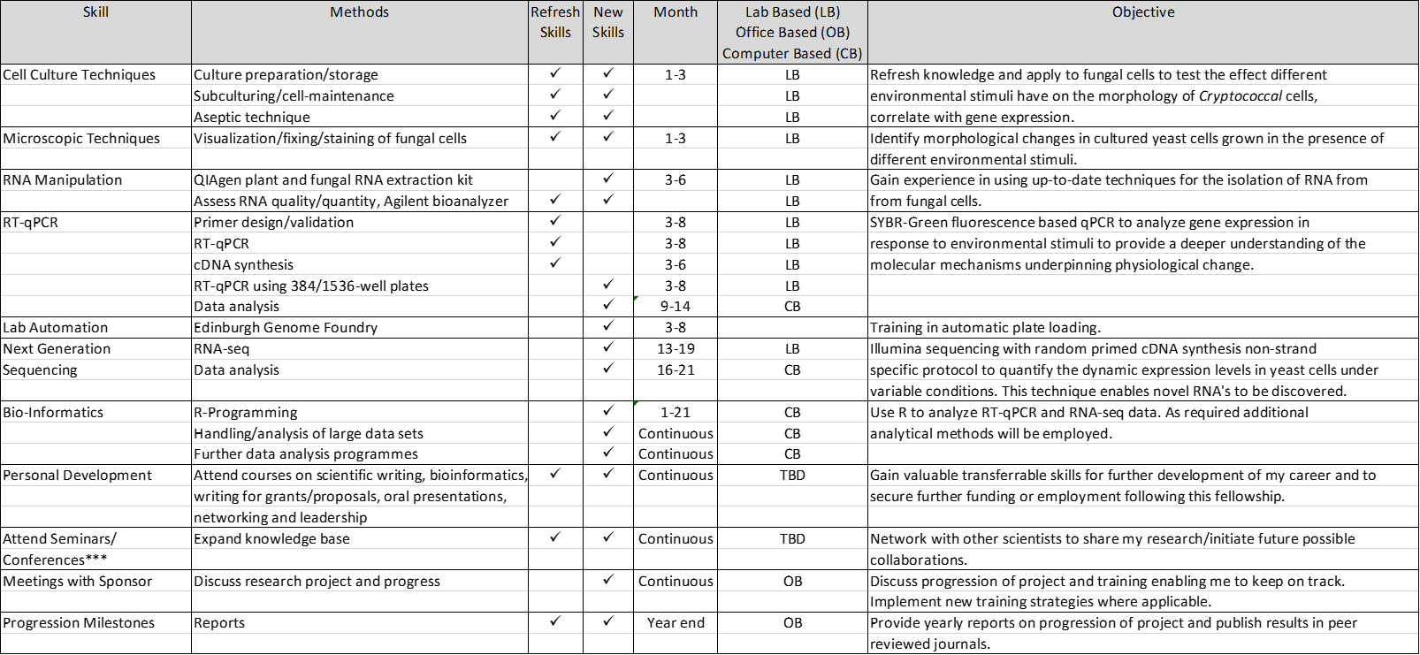

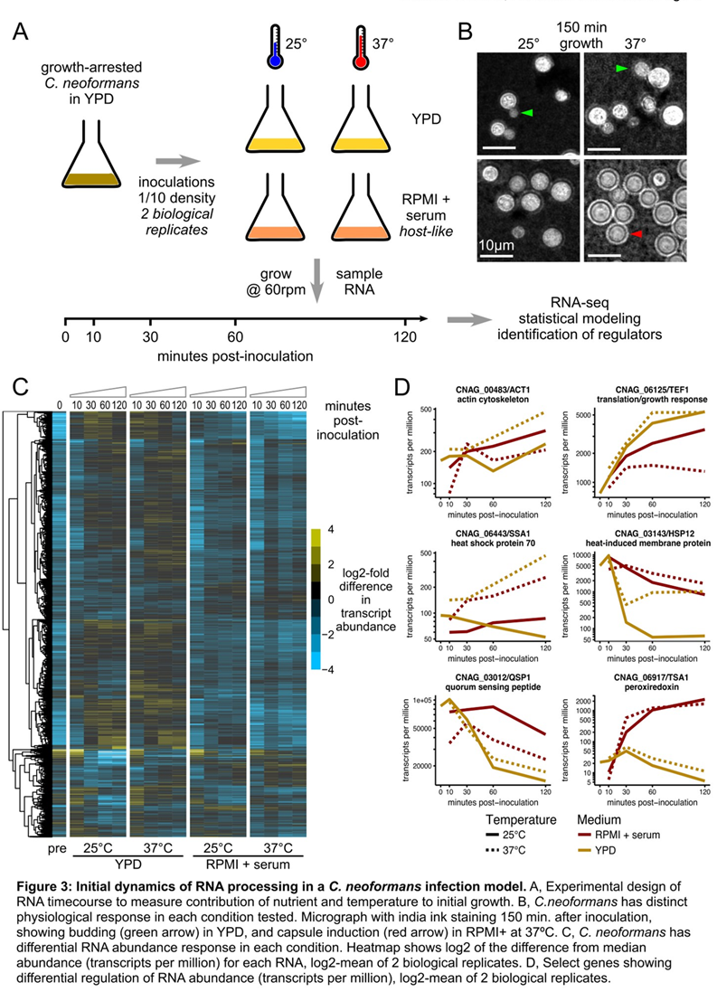**Appendix 2:** Contribution of host factors and temperature in shapinginitial growth.

**Appendix 3:** Aim 1 experimental plan: Dissection of serum components

|  |  |  |  |  |  |  |
| --- | --- | --- | --- | --- | --- | --- |
| Media | No Serum  (Serum starvation) | FBS | Charcoal stripped FBS | Albumin | 25⁰C | 37⁰C |
| RPMI-1640 | ✓ |  |  |  | ✓ | ✓ |
|  |  | ✓ |  |  | ✓ | ✓ |
|  |  |  | ✓ |  | TBD | TBD |
|  |  |  |  | ✓ | TBD | TBD |
| YPD | ✓ |  |  |  | ✓ | ✓ |
|  |  | ✓ |  |  | ✓ | ✓ |
|  |  |  | ✓ |  | TBD | TBD |
|  |  |  |  | ✓ | TBD | TBD |

**Appendix 4:** Aim 1 experimental plan: Dissection of media components

|  |  |  |
| --- | --- | --- |
| Media | 25⁰C | 37⁰C |
| RPMI-1640 | ✓ | ✓ |
| RPMI-1640  (no phenol red) | TBD | ✓ |
| MEM | ✓ | ✓ |

**Appendix 5:** Aim 2 experimental plan.

|  |  |  |  |  |  |
| --- | --- | --- | --- | --- | --- |
| RPMI | Supplemented with | GA-Cn-YPD  (fast growing) |  | GA-Cn-YND  (starved) |  |
|  |  | 25⁰C | 37⁰C | 25⁰C | 37⁰C |
|  | NAG | TBD | ✓ | TBD | ✓ |
|  | NAM | TBD | ✓ | TBD | ✓ |
|  | Muramyl dipeptide | TBD | ✓ | TBD | ✓ |
|  | LPS | TBD | ✓ | TBD | ✓ |
|  | TA | TBD | ✓ | TBD | ✓ |